HANDSMEN THREADS
Salesforce CRM Project Documentation
Project Name: HandsMen Threads – Salesforce CRM
Platform: Salesforce
Business Domain: Premium Men's Fashion and Bespoke Tailoring

Name: Bommareddy Aswini Reddy
Roll No: 238W1A5408
Section: AI&DS – A
Velagapudi Ramakrishna Siddhartha
Engineering College

1. Project Overview
HandsMen Threads is a Salesforce CRM implementation developed for a premium men's fashion and bespoke tailoring business. The project centralizes customer, product, order, inventory and marketing information within Salesforce to provide a structured and connected business environment.
The CRM is designed to improve customer management, order handling and inventory monitoring while reducing repetitive manual activities through Salesforce automation. The implementation includes custom objects, fields, relationships, formula fields, validation rules, a dedicated Lightning application, user and security configuration, email communication, Salesforce Flows, Apex programming and asynchronous processing.
The major business functionalities implemented in the project are customer management, order management, inventory management, loyalty-status automation, order-confirmation communication, low-stock notification and scheduled inventory processing.
2. Objectives
The main objective of the HandsMen Threads Salesforce CRM project is to provide a centralized platform for managing the major business activities of the organization.
The project objectives are:
- Centralize customer, product, order, inventory and marketing information.
- Create a structured Salesforce data model for the business.
- Maintain data accuracy through validation rules and formula fields.
- Provide a dedicated Lightning application for accessing project records.
- Automate customer communication after order confirmation.
- Automatically update customer loyalty status according to purchase history.
- Generate low-stock notifications when inventory falls below the configured threshold.
- Implement programmatic business validation using Apex and Apex Trigger.
- Implement bulk inventory processing using Batch Apex.
- Schedule inventory processing to run automatically at midnight.
- Control system access through Salesforce profiles, roles, users and permission sets.
3. Phase 1: Requirement Analysis & Planning
3.1 Understanding Business Requirements
HandsMen Threads requires a CRM system capable of managing information related to customers, products, orders, inventory and marketing campaigns in a centralized environment.
The main business requirements identified for the project were:
- Maintain customer information including contact details and loyalty information.
- Maintain product information including SKU, price and stock quantity.
- Manage customer orders using order status, quantity and total amount.
- Associate orders with customers.
- Associate products with inventory records.
- Maintain inventory and warehouse information.
- Automatically send an email when an order is confirmed.
- Automatically notify the inventory team when stock falls below five.
- Automatically update customer loyalty status based on total purchases.
- Process low-stock products through batch processing.
- Schedule inventory processing every day at midnight.
- Provide role-based and permission-based access to Salesforce users.
Project Scope
The project scope covers the configuration and development of the Salesforce CRM required to support the identified business requirements.
The implementation includes:
- Custom Salesforce objects.
- Custom fields.
- Lookup and Master-Detail relationships.
- Formula fields.
- Validation rules.
- Custom tabs.
- Lightning App configuration.
- User management.
- Profile and role configuration.
- Permission Set configuration.
- Email Templates.
- Email Alerts.
- Record-Triggered Flows.
- Schedule-Triggered Flow.
- Apex Class.
- Apex Trigger.
- Batch Apex.
- Scheduled Apex.
The implementation does not document components that were not completed, such as LWC development, Approval Process, Workflow Rules, Process Builder, Duplicate Rules, Matching Rules, Field History Tracking or Sharing Rules.
3.3 Data Model Design
The Salesforce data model consists of five custom objects:
HandsMen Customer stores customer information including email, phone, loyalty status and total purchases.
HandsMen Product stores product information such as SKU, price and stock quantity.
HandsMen Order stores order information including order status, quantity, total amount and customer association.
Inventory stores warehouse and stock information and is associated with the corresponding product.
Marketing Campaign stores campaign information including campaign dates and customer association.
The main relationships are:
- Marketing Campaign → HandsMen Customer — Lookup
- HandsMen Product → HandsMen Order — Lookup
- HandsMen Order → HandsMen Customer — Lookup
- Inventory → HandsMen Product — Master-Detail
4. Phase 2: Salesforce Development – Backend & Configurations
4.1 Salesforce Environment
The Salesforce org was used as the development and runtime environment for the HandsMen Threads implementation.
The project components were configured using Salesforce Setup, Object Manager, App Manager, Flow Builder and Developer Console.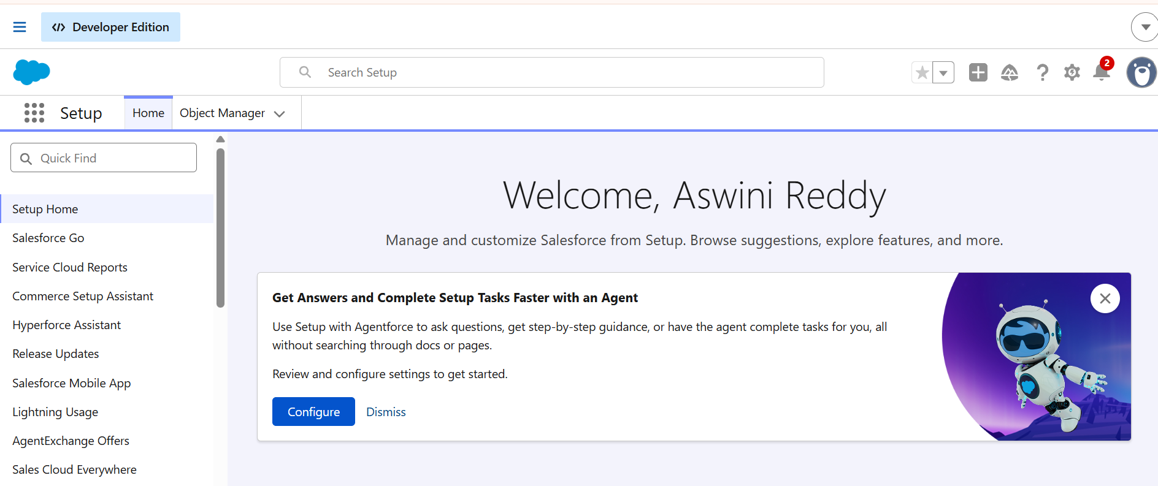
4.2 Custom Objects
Five custom objects were created for the project:
- HandsMen Customer
- HandsMen Order
- HandsMen Product
- Inventory
- Marketing Campaign
These objects form the core data foundation of the CRM.
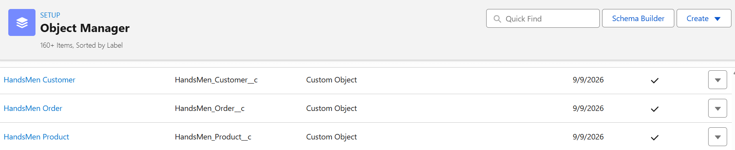
4.3 Custom Fields
HandsMen Customer
The HandsMen Customer object contains:
- Email – Email field used to store the customer's email address.
- Phone – Phone field used to store the customer's contact number.
- Loyalty Status – Picklist containing Gold, Silver and Bronze.
- Total Purchases – Number field used to store purchase history.
- FirstName – Text field.
- LastName – Text field.
- Full Name – Formula field that combines FirstName and LastName.
HandsMen Product
The HandsMen Product object contains:
- SKU – Product identifier.
- Price – Product price.
- Stock Quantity – Product stock quantity.
HandsMen Order
The HandsMen Order object contains:
- Order Number – Record Name.
- Status – Picklist containing Pending, Confirmed and Rejection.
- Quantity – Order quantity.
- Total Amount – Order amount.
- Customer – Lookup relationship with HandsMen Customer.
- Product – Lookup relationship as configured in the project.
Inventory
The Inventory object contains:
- Record Name – Auto Number.
- Warehouse – Warehouse information.
- Stock Quantity – Inventory quantity.
- Stock Status – Formula field used to determine the stock condition.
- Product – Master-Detail relationship with HandsMen Product.
Marketing Campaign
The Marketing Campaign object contains:
- Campaign Name – Record Name.
- Start Date – Campaign starting date.
- End Date – Campaign ending date.
- HandsMen Customer – Lookup relationship with HandsMen Customer.
4.4 Formula Fields
Two formula fields were implemented.
Full Name
The Full Name field automatically combines the customer's first and last name.
Formula:
FirstName__c + " " + LastName__c
Business Purpose:
Provides a combined customer name without requiring users to enter a separate full-name value.
Stock Status
The Stock Status field evaluates inventory quantity and displays the corresponding stock condition.
Formula:
IF(Stock_Quantity__c > 10, "Available", "Low Stock")
Business Purpose:
Provides users with an immediate indication of inventory availability.
4.5 Validation Rules
Validation rules were configured to maintain data integrity.
HandsMen Order – Total Amount
The validation rule checks whether the total amount is less than or equal to zero.
Condition:
Total_Amount__c <= 0
Error Message:
Please Enter Correct Amount
This prevents invalid order amounts from being saved.
Inventory – Stock Quantity
The validation rule prevents an invalid inventory quantity.
Condition:
Stock_Quantity__c <= 0
Error Message:
the inventory count is never less than zero.
This protects the inventory data from invalid quantity values.
HandsMen Customer – Email
The Email validation rule checks the configured Gmail condition.
Condition:
NOT CONTAINS(Email, "@gmail.com")
Error Message:
Please fill Correct Gmail
This validation provides a basic format restriction for customer email data.
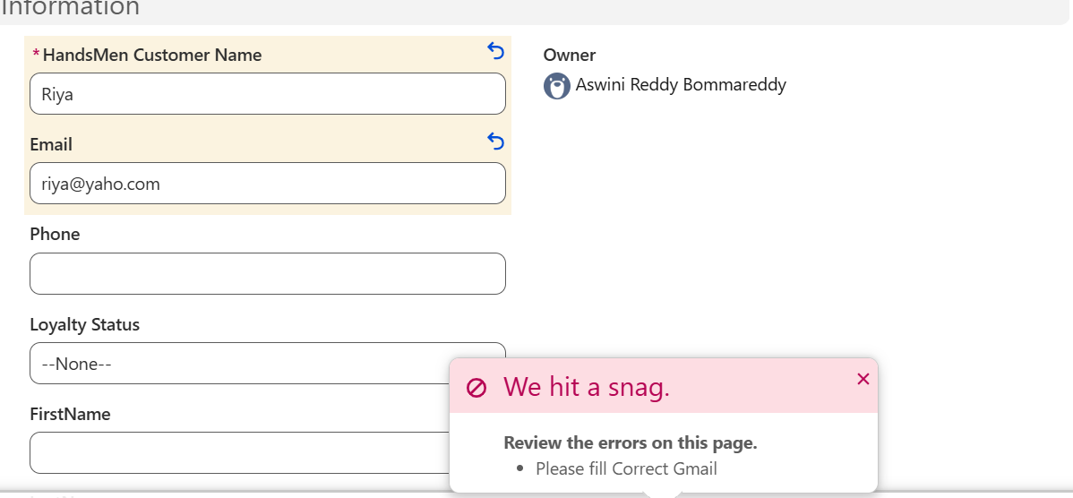
4.6 Email Templates
Three Classic Email Templates were created using HTML with Classic Letterhead.
Order_Confirmation_Email
Subject:
Your Order has been Confirmed!
Purpose:
Used for communicating order confirmation to customers.
Low_Stock_Alert
Subject:
Low Stock Alert
Purpose:
Used to notify the relevant team when product inventory is low.
Loyalty_Program_Email
Subject:
Loyalty Program Update
Purpose:
Used to communicate loyalty-status updates to customers.
A Classic Letterhead was also configured to support the HTML email templates.
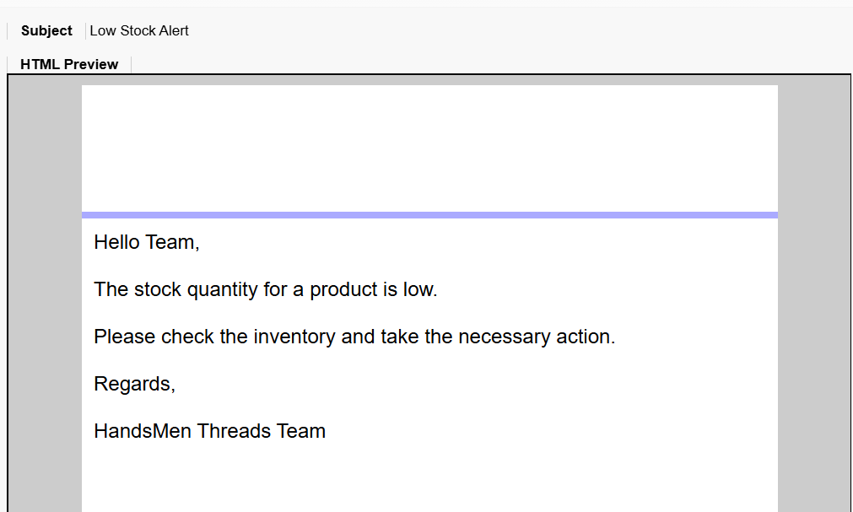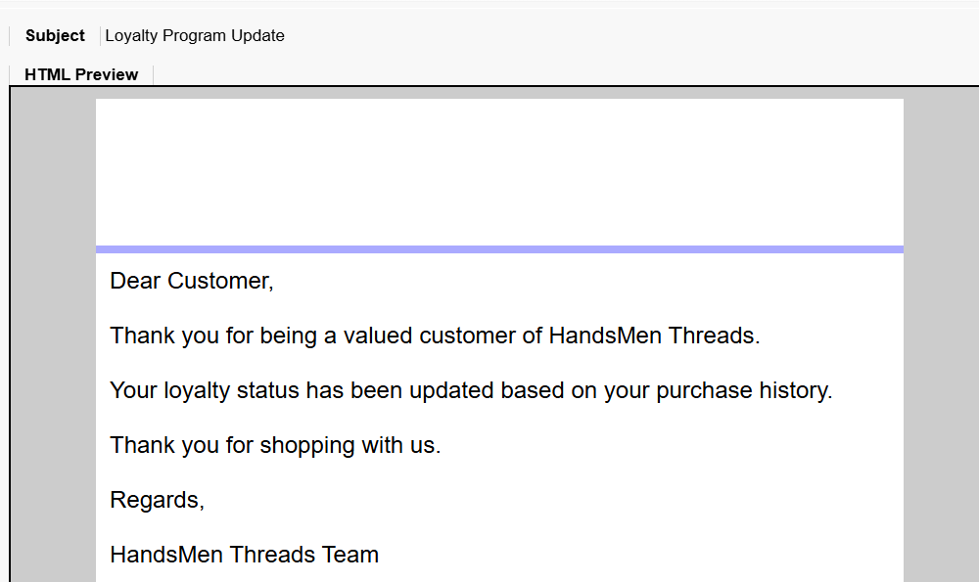
4.7 Email Alerts
The following Email Alerts were created:
- Order Confirmation Email Alert
- Low Stock Alert
- Loyalty Program Email
These alerts are used by the Salesforce automation processes to send the configured email communications.
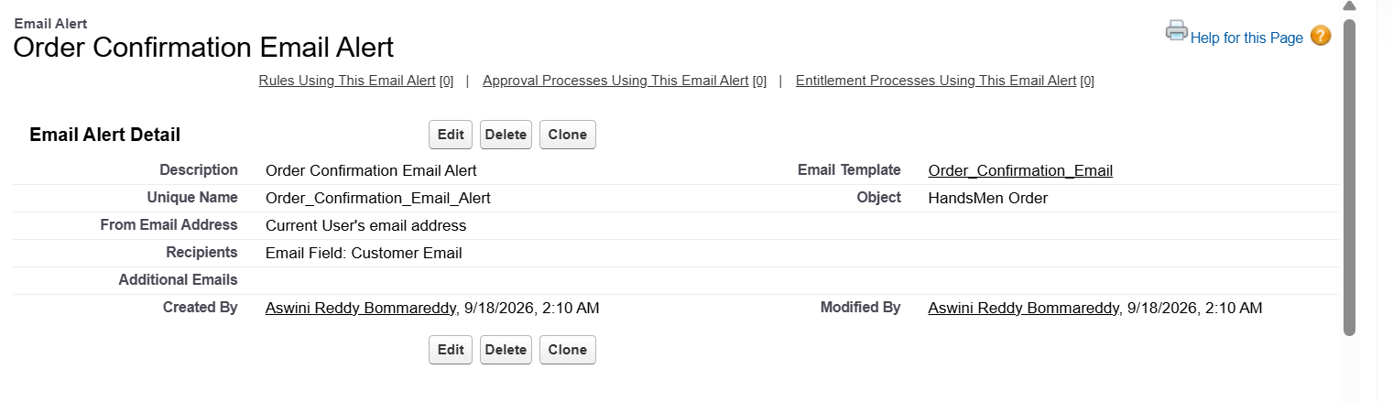
4.8 Order Confirmation Flow
A Record-Triggered Flow named Order Confirmation Flow was created on the HandsMen Order object.
The Flow is configured to run when an existing order is updated and its status meets the Confirmed condition.
The configuration includes:
- Object: HandsMen Order
- Trigger: Record Updated
- Condition: Status = Confirmed
- Entry Condition: Only when a record is updated to meet the condition
- Action: Send Email Alert
- Email Alert: Order Confirmation Email Alert
- Record ID: $Record.Id
Business Purpose:
Automatically sends an order-confirmation email when an order becomes confirmed.
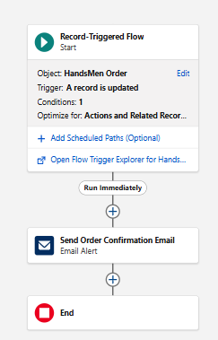
4.9 Stock Alert Flow
A Record-Triggered Flow named Stock Alert Flow was created on the Inventory object.
The Flow is configured to respond when an inventory record is created or updated and the stock quantity is below five.
The configuration includes:
- Object: Inventory
- Trigger: Record Created or Updated
- Condition: Stock Quantity < 5
- Update Behaviour: Every time a record is updated and meets the condition requirements
- Action: Send Email Alert
- Alert: Low Stock Alert
Business Purpose:
Automatically notify the relevant inventory team when stock falls below the configured threshold.
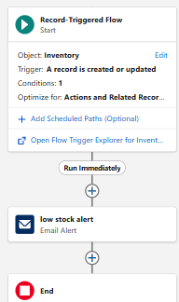
4.10 Loyalty Status Update Flow
A Schedule-Triggered Flow named Loyalty Status Update Flow was created.
The Flow runs daily and retrieves HandsMen Customer records. The retrieved records are processed using a Loop and a Decision element.
The Flow uses:
- Schedule-Triggered Flow
- Frequency: Daily
- Get Records: HandsMen Customer
- Record Retrieval: All customer records
- Loop: First to Last
- Decision: Based on Total Purchases
- Update Records: Updates Loyalty Status
The configured loyalty conditions are:
Total Purchases | Loyalty Status
Greater than 1000 | Gold
Less than 500 | Bronze
Default | Silver
Business Purpose:
Automatically maintain customer loyalty status according to purchase history.
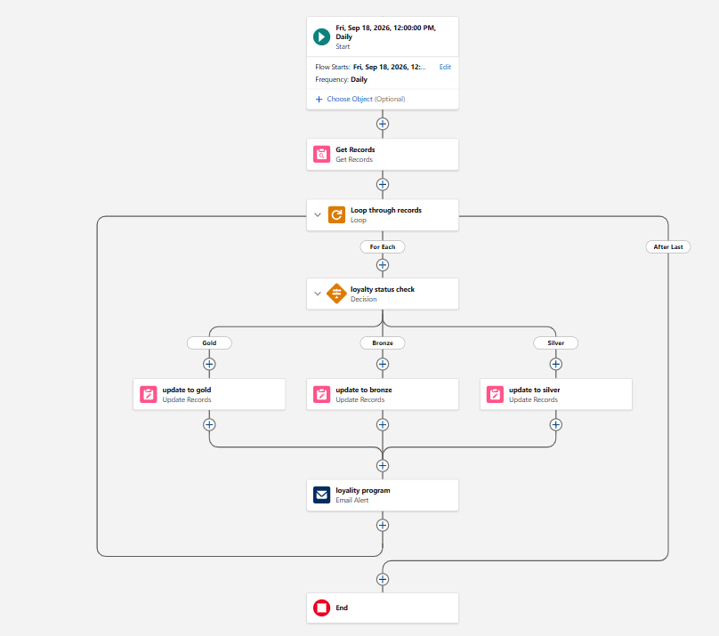
4.11 Apex Class – OrderTriggerHandler
An Apex class named OrderTriggerHandler was implemented to perform programmatic validation of order quantities.
The class contains a method named validateOrderQuantity() which processes HandsMen Order records.
The configured business rules are:
- For Confirmed, Quantity must be greater than 500.
- For Pending, Quantity must be greater than 200.
- For Rejection, Quantity must be exactly 0.
The class uses addError() to prevent invalid order records from being saved.
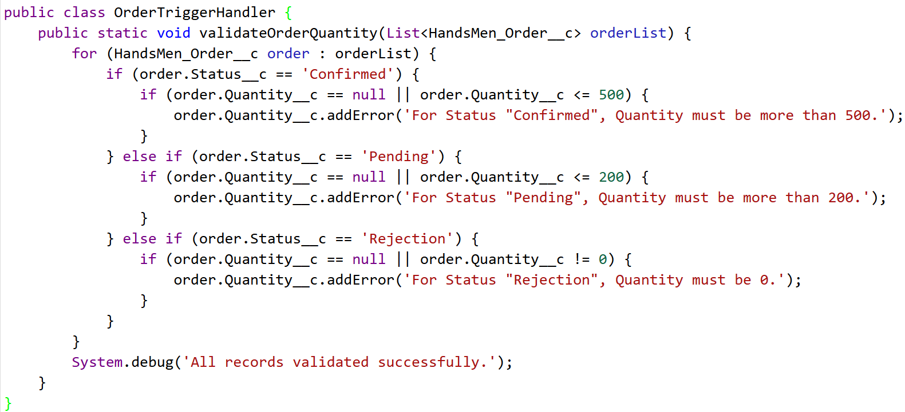
4.12 Apex Trigger – OrderTrigger
An Apex Trigger named OrderTrigger was created on HandsMen_Order__c.
The Trigger executes during:
- Before Insert
- Before Update
The Trigger calls:
OrderTriggerHandler.validateOrderQuantity(Trigger.new)
This separates the Trigger event handling from the actual business validation logic.
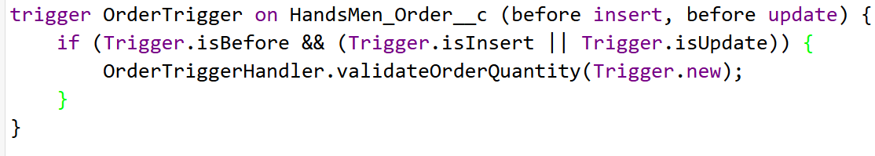
4.13 Batch Apex – InventoryBatchJob
An asynchronous Apex class named InventoryBatchJob was implemented.
The class implements:
- Database.Batchable<SObject>
- Schedulable
The batch process is configured to identify low-stock product records and increase their stock quantity by 50.
The main implementation details are:
- Low-stock condition: Stock Quantity < 10
- Restocking operation: Increase Stock Quantity by 50
- Batch size: 200
- Finish message: Inventory Sync Completed
The class also includes error handling through DmlException.
Implementation note: The configured source currently uses Product__c in the SOQL query while processing records as HandsMen_Product__c. The final API name should be verified in the Salesforce org before execution.
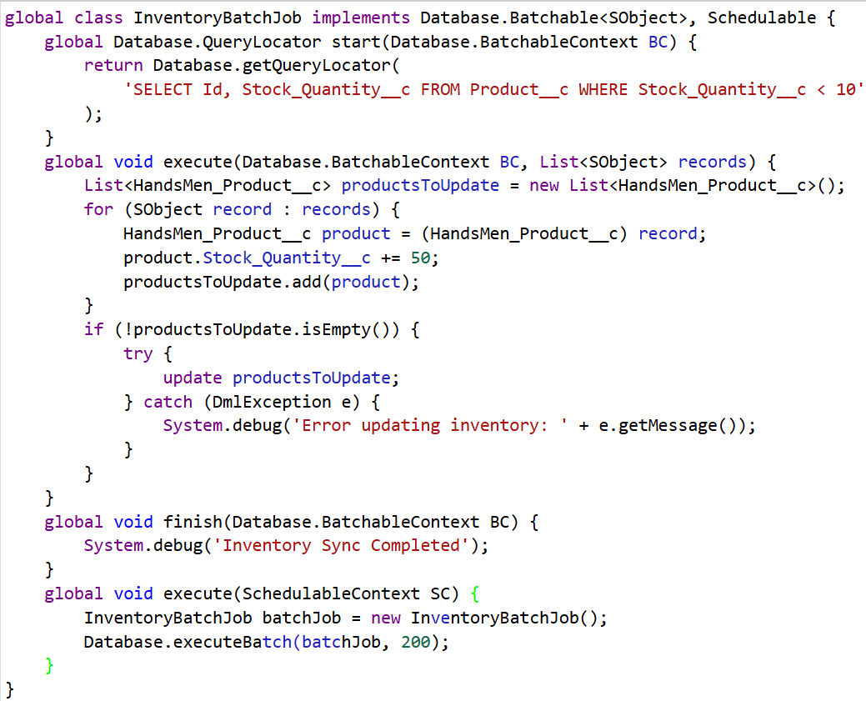
4.14 Scheduled Apex – Daily Inventory Sync
The InventoryBatchJob was scheduled through the Developer Console using Execute Anonymous.
The scheduled job is named:
Daily Inventory Sync
The configured scheduling command is:
System.schedule('Daily Inventory Sync', '0 0 0 * * ?', new InventoryBatchJob());
This schedule is configured for daily execution at midnight.
5. Phase 3: UI/UX Development & Customization
5.1 Lightning App Setup through App Manager
A custom Lightning application named HandsMen Threads was created through App Manager.
The application description is:
Salesforce CRM application for streamlining operations, enhancing customer experience, and optimizing inventory management.
The configured navigation items are:
- HandsMen Customer
- HandsMen Order
- Inventory
- HandsMen Product
- Reports
- Dashboard
- Account
- Contact
- Marketing Campaign
The application provides a single navigation environment for the main CRM components.
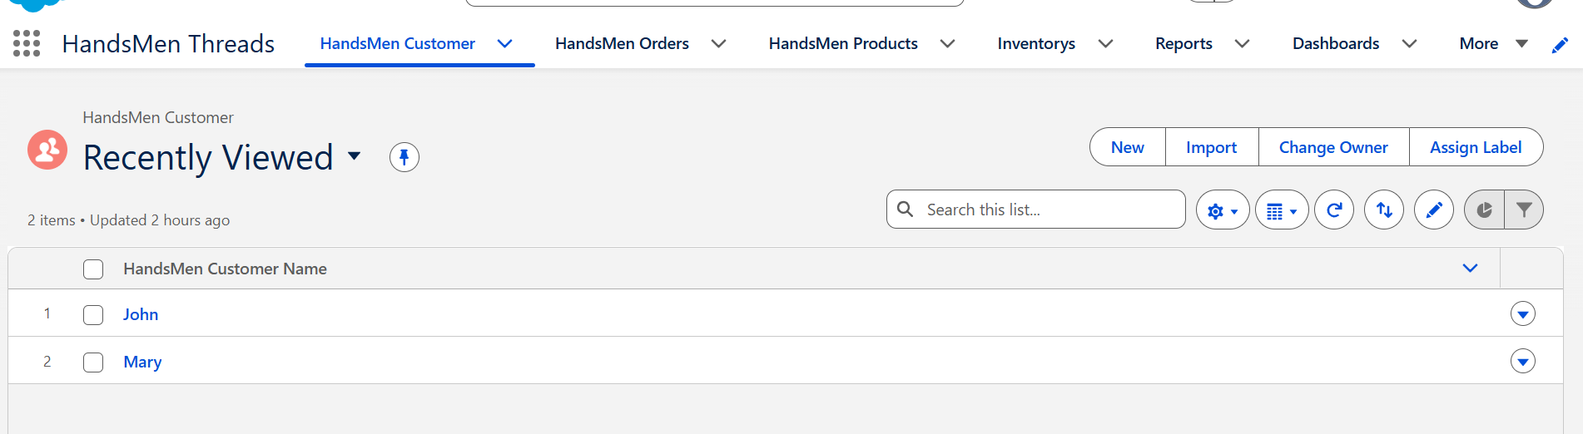
5.2 Custom Tabs
Custom tabs were configured for the main project objects so that users can directly access business records from Salesforce.
The configured custom tabs are:
- HandsMen Customer
- HandsMen Order
- HandsMen Product
- Inventory
- Marketing Campaign
5.3 User Management
Three Salesforce users were created for the project.
Niklaus Mikaelson
- Role: Sales
- User License: Salesforce
- Profile: Platform 1
Kol Mikaelson
- Role: Inventory
- User License: Salesforce
- Profile: Platform 1
Daniel Mikaelson
- Role: Marketing
- User License: Salesforce
- Profile: Platform 1
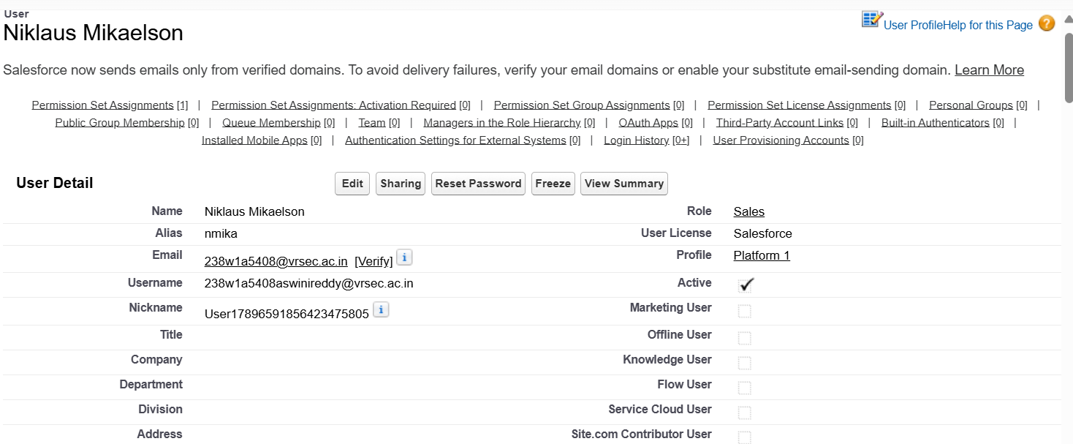
6. Phase 4: Data Migration, Testing & Security
6.1 Security Configuration
Security was implemented through Profiles, Roles, Role Hierarchy, Users and Permission Set.
Profile – Platform 1
A custom profile named Platform 1 was created by cloning the Standard User profile.
The profile was configured with custom object access for:
- HandsMen Product
- Inventory
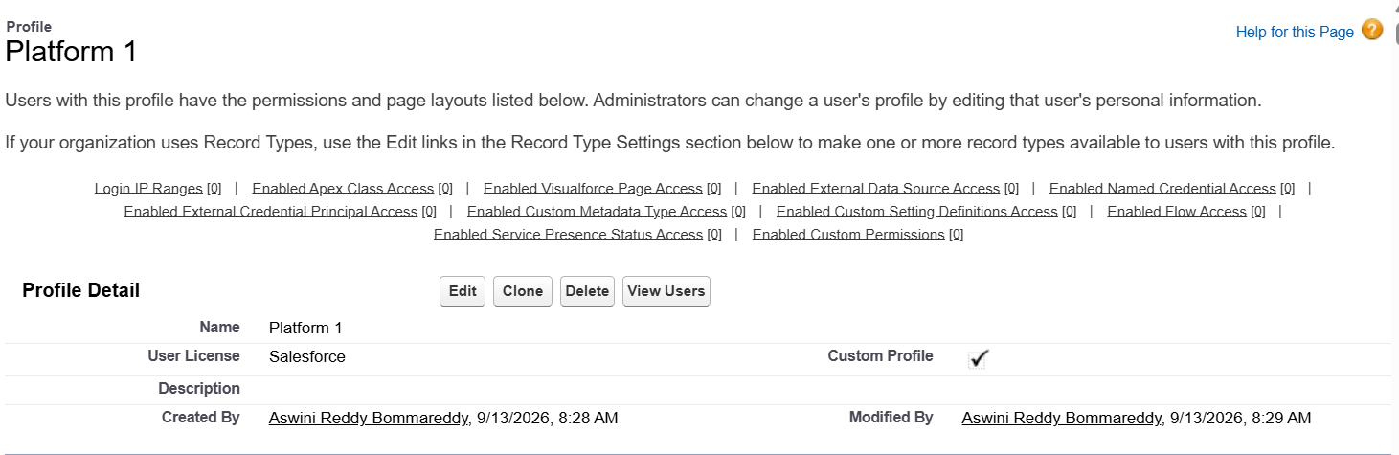
Role Hierarchy
The role hierarchy was created under the CEO role.
The structure is:
CEO
├── Sales
├── Inventory
└── Marketing
This provides a basic organizational structure for the project users.
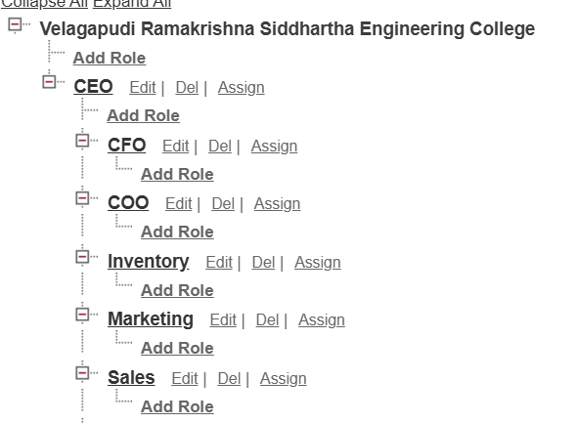
Permission Set
A Permission Set named:
Permission_Platform_1
was created and assigned to the three project users.
The configured permissions include:
HandsMen Customer
- Read
- Create
- Edit
- Delete
HandsMen Order
- Read
- Create
- Edit
- Delete
Assigned users:
- Niklaus Mikaelson
- Kol Mikaelson
- Daniel Mikaelson
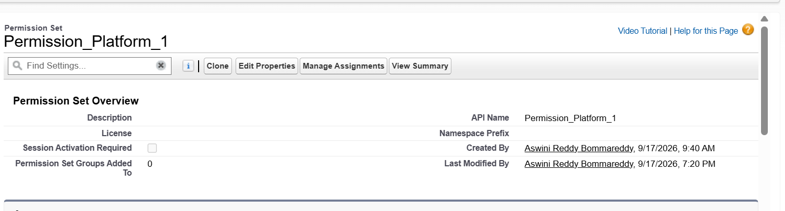
7. Phase 5: Deployment, Documentation & Maintenance
7.1 Deployment Strategy
The HandsMen Threads components were configured within the Salesforce development environment.
7.2 Maintenance and Monitoring
The implemented Salesforce solution can be maintained and monitored through regular review of its configuration and automated processes.
Maintenance activities include:
- Reviewing Flow activation and Flow errors.
- Monitoring scheduled and asynchronous Apex jobs.
- Maintaining user and permission assignments.
- Reviewing validation rules when business requirements change.
- Updating email templates and email alerts when communication requirements change.
- Reviewing inventory and product information.
- Maintaining the Lightning App navigation as new components are introduced.
7.3 Troubleshooting Approach
The troubleshooting approach is based on identifying the Salesforce component responsible for an issue and reviewing its configuration.
For data-related issues, the relevant object fields, relationships and validation rules should be checked.
For Flow-related issues, the Flow start conditions, Decision elements, actions and activation status should be reviewed.
For Apex-related issues, the Trigger events, Apex class logic and Developer Console information should be reviewed.
For scheduled processing issues, Scheduled Jobs and Apex Jobs should be checked.
For email-related issues, the email template, email alert and available recipient configuration should be reviewed.
8. Future Enhancements
The project can be extended with additional Salesforce and AI capabilities in the future.
Possible enhancements include:
- AI-based product recommendations.
- AI-based demand forecasting.
- Customer recommendation systems.
- Chatbot integration for customer support.
- Advanced inventory prediction.
- Personalized marketing automation.
- Enhanced dashboards and business analytics.
- Integration with external e-commerce systems.
- Lightning Web Components for richer user interfaces.
These future enhancements are consistent with the template's recommendation to mention possible chatbot and AI-based improvements.
9. Conclusion
HandsMen Threads is a Salesforce CRM implementation designed to centralize business information and automate important operational activities for a premium men's fashion and bespoke tailoring business.
The completed implementation includes five custom Salesforce objects, custom fields, Lookup and Master-Detail relationships, formula fields, validation rules, custom tabs and a dedicated Lightning application. The security configuration includes a custom Platform 1 profile, role hierarchy, project users and a permission set.
The project also includes Classic Email Templates, Email Alerts, Record-Triggered Flows for order confirmation and stock alerts, a Schedule-Triggered Flow for loyalty management, an Apex class and trigger for order validation, Batch Apex for bulk inventory processing and Scheduled Apex for daily inventory synchronization.
The solution demonstrates the use of Salesforce declarative configuration together with Apex and asynchronous processing to create a structured CRM system for customer management, order handling, inventory monitoring, communication and automation.

